VOANHKHA OPTIMIZATION TOOLBOX HISTORY LOG

**08 Aug 2017**  
Finish UNCONSTRAINED OPTIMIZATION (exact line search, backtracking line search methods, together with gradient descent, steepest descent, and Newton main algorithm).

|  |
| --- |
| %% Gradient Descent  clear all  f = 'exp(x(1)+3*x(2)-0.1) + exp(x(1)-3*x(2)-0.1) + exp(-x(1)-0.1);';  [xf1_all, f1_all] = Descent_Kha(f, [-1; 1] ,'gradient' ,'exact');  [xf2_all, f2_all] = Descent_Kha(f, [-1; 1] ,'gradient' ,'backtrack');  p_opt = 2.559266696658216;  err1 = f1_all - p_opt;  err2 = f2_all - p_opt;  figure; plot(log10(err1)); hold on; plot(log10(err2)); |

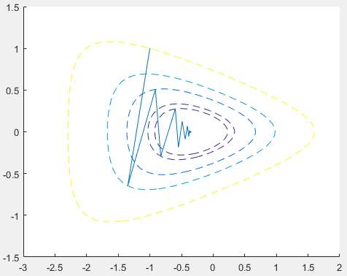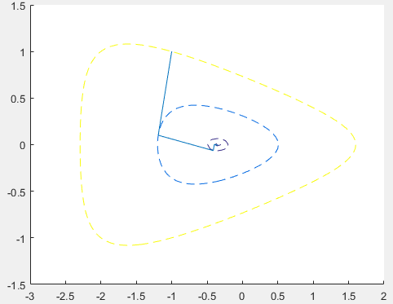

Fig 9.3 p.471 Fig 9.5 p.472

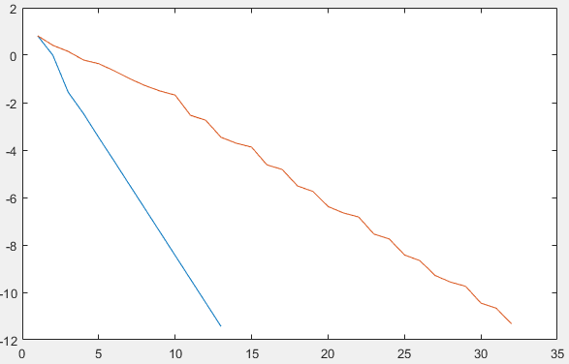Fig 9.4 p.471

|  |
| --- |
| %% Steepest Descent  [xf3_all, f3_all] = Descent_Kha(f, [-1; 1] ,'steepest' ,'backtrack',[2 0; 0 8]);  [xf4_all, f4_all] = Descent_Kha(f, [-1; 1] ,'steepest' ,'backtrack', [8 0;0 2]);  err3 = f3_all - p_opt;  err4 = f4_all - p_opt;  figure; plot(log10(err3)); hold on; plot(log10(err4)); |

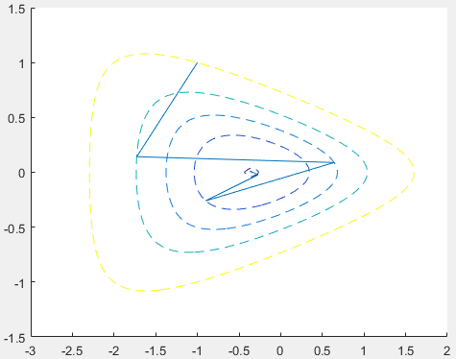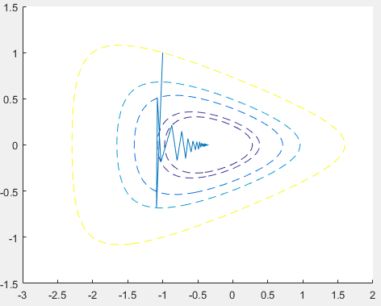

Fig 9.11 p.481 Fig 9.12 p.482

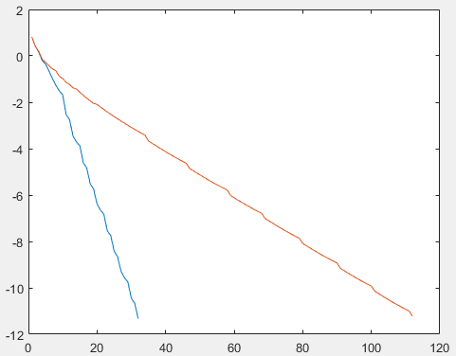

Fig 9.13 p.482

|  |
| --- |
| %% Newton, change epsilon to 1e-15 instead of 1e-10 for more accuracy  [xf5_all, f5_all] = Descent_Kha(f, [-1; 1] ,'newton' ,'backtrack');  err5 = f5_all - p_opt;  figure; plot(log10(err5)); |

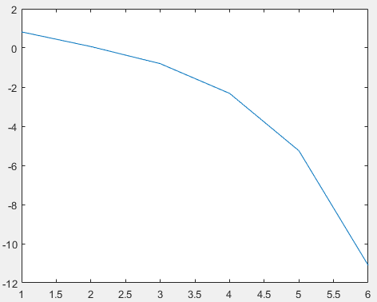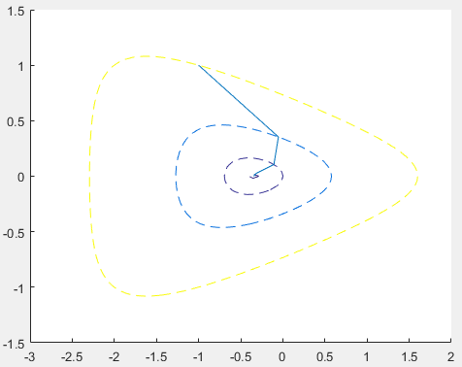  
 Fig 9.19 p.481 Fig 9.20 p.493

FULL ALGORITHM

Main Algorithm

|  |
| --- |
| %% UNCONSTRAINED OPTIMISATION  % Version 1.0  % Author: Kha Vo (voanhkha@yahoo.com)    %% Instruction  % Example:  % f1 = 'exp(x(1)+3*x(2)-0.1) + exp(x(1)-3*x(2)-0.1) + exp(-x(1)-0.1);';  % [xf1_all, f1_all] = Descent_Kha(f, [-1; 1] ,'gradient' ,'exact');    % FUNCTION EXAMPLES  % f = '1/2*(x(1)^2 + 10*x(2)^2);' % for Figure 9.2  % f = 'exp(x(1)+3*x(2)-0.1) + exp(x(1)-3*x(2)-0.1) + exp(-x(1)-0.1);' % for Figure 9.3  % f = 'norm(A*x - b)^2;    % METHOD  % opt_method = 'gradient' or 'steepest' or 'newton'  % linesearch_method = 'exact' or 'backtrack'  % P = [8 0; 0 2]; % only for steepest descent    function [x_all, f_all] = Descent_Kha(f, x0, opt_method, linesearch_method, P_steepest)  %% TOLERANCE  epsilon = 1e-10;    %% PLOT OPTIONS  plotflag = 1;  n_contours = 5; % number of first contours plotted  plot_range = [-3 2 -1.5 1.5]; %[-3 3 -3 3] [-5 5 -12 12]    %% MAIN PROGRAM  if nargin < 5  P_steepest = eye(size(x0));  end  if strcmp(opt_method,'steepest')  P_inv = inv(P_steepest);  end    x = sym('x', [size(x0) 1]);  eval(strcat('f = ', f));  grad_f = gradient(f,x); % calculate gradient of f as a function of x  hess_f = hessian(f,x);  x_value = x0; % initial point x0  f_value = double(subs(f, x, x0)); % initial f(x0)  grad_value = double(subs(grad_f, x, x0));  x_all = []; % store all values of x after each iteration of index k  f_all = []; % store all values of f(x)      k = 0; % iteration count    while 1    switch opt_method  case 'gradient'  Delta_x = -grad_value;  cri = norm(grad_value)^2;  case 'steepest'  Delta_x = -P_inv*grad_value;  cri = norm(grad_value)^2;  case 'newton'  hess_value = double(subs(hess_f, x, x_value));  Delta_x = -(hess_value\grad_value); % equivalent to -inv(hess_value)*grad_value  lambda_sq = grad_value'*(hess_value\grad_value);  cri = lambda_sq/2;  end      % ------ Begin Stopping Criterion ----------%  if cri <= epsilon  break;  end  % -------- End Stopping Criterion ------------%  x_all = [x_all, x_value];  f_all = [f_all, f_value];  k = k + 1;    switch linesearch_method  case 'backtrack'  t = BackTrack_LineSearch(f, grad_f, x_value, Delta_x);  case 'exact'  t = Exact_LineSearch(f, grad_f, x_value, Delta_x);  end    x_value = x_value + t*Delta_x;  f_value = double(subs(f, x, x_value));  grad_value = double(subs(grad_f, x, x_value));    end        if plotflag == 1  figure  hold on  fcontour(f,plot_range,'LevelList', f_all(1:n_contours), 'LineStyle', '--')  line(x_all(1,:) , x_all(2,:));  end |

Line search methods

|  |
| --- |
| function t = BackTrack_LineSearch(f, grad_f, x_current, Delta_x)  % Author: Kha Vo (voanhkha@yahoo.com)  % Using backtracking line search mentioned in Chapter 9, Convex  % Optimization book, Boyd.  alpha = 0.1;  beta = 0.7;  t = 1;  stopflag = 0;  x = sym('x', [size(x_current) 1]);  while stopflag ~= 1;  if (double(subs(f, x, x_current + t*Delta_x)) > double(subs(f, x, x_current))...  + alpha*t*double(subs(grad_f, x, x_current))'*Delta_x)  t = beta*t;  else stopflag = 1;  end  end  function t = Exact_LineSearch(f, grad_f, x_value, Delta_x)  % Author: Kha Vo (voanhkha@yahoo.com)  % Using Golden Section Method as mentioned in Appendix C,  % Nonlinear Programming book, Bertsekas.  tolerance = 1e-5;  tau = (3-sqrt(5))/2;  t = 1;  stopflag = 0;  x = sym('x', [size(x_value) 1]);    % Determine first two ends (a1,a2) by searching for f'(a1)<0 and f'(a2)>0  a2 = 0;  dev_a2 = -1;  while dev_a2 < 0  a1 = a2;  a2 = a2 + 0.5;  dev_a2 = double(subs(grad_f, x, x_value + a2*Delta_x))'*Delta_x;  end    % Golden Section Method  while stopflag ~= 1;  if a2-a1 > tolerance  b1 = a1 + tau*(a2 - a1);  b2 = a2 - tau*(a2 - a1);  ga1 = double(subs(f, x, x_value + a1*Delta_x));  ga2 = double(subs(f, x, x_value + a2*Delta_x));  gb1 = double(subs(f, x, x_value + b1*Delta_x));  gb2 = double(subs(f, x, x_value + b2*Delta_x));  if gb1 < gb2  if ga1 <= gb1  a2 = b1;  else  a2 = b2;  end  elseif gb1 > gb2  if gb2 >= ga2  a1 = b2;  else  a1 = b1;  end  else  a1 = b1; a2 = b2;  end  else stopflag = 1;  end    t = (a2+a1)/2;  end |